ICT 214 Advance Database

Name: Sushant Ghimire Khatri

Student ID: 985552

Task 1 : Create a Crow’s Foot ER Diagram for the following business Rules. Write all appropriate connectivities and cardinalities in the ERD. Create A Data dictionary by adding some attributes to each entity.

* A department employs many employees, but each employee is employed by one department.
* Some employees known as “Rovers,” are not assigned to any department.
* A division operates many departments, but each department is operated by one division.
* An employee may be assigned to many projects and project may have many employees assigned to it.
* A project must have at least one employee assigned to it.
* One of the employees manages each department and each department is managed by only one employee.
* One of the employees runs each division and each division is run by only one employee.

1. Identifying the entites and their attributes

Entities: Department

Attributes:

- DepartmentID

- DepartmentName

- Location

Entities: Employee

Attributes:

* EmployeeID(Primary Key)
* FirstName
* LastName
* Position
* DateOfBirth
* HireDate
* IsRover
* DeaprtmentID(Foreign Key)
* DivisionID(Foreign key)

Entities: Division

Attributes:

* DivisionID(Primary Key)
* DivisionName
* Headquarters

Entites: Project

Attributes:

* ProjectID(primary Key)
* ProjectNAme
* StartDate
* EndDate

1. Er Model.

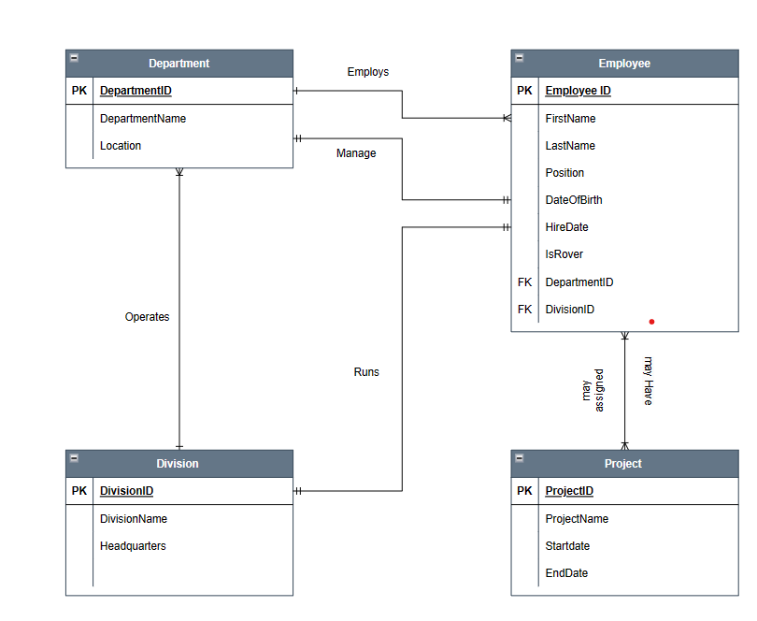

Preparing a relation Database model.

|  |  |  |  |
| --- | --- | --- | --- |
| Department | Employee | Division | Project |
| DepartmentID(Primary Key)  DepartmentName  Location | EmployeeID(Primary Key)  FirstName  LastName  Position  DateOfBirth  HireDate  IsRover  DepartmentID(foreign key)  DivisionID(Foreign key0 | DivisionID(Primary Key)  DivisionNAme  Headquarters | ProjectID(Primary Key)  ProjectNAme  Startdate  EndDate |

Data Dictionary

* + Department Table
* DepartmentID(PK): Unique identifier for each department
* DepartmentNAme: Name of Department
* Location: Location of department

|  |  |  |  |  |  |
| --- | --- | --- | --- | --- | --- |
| Department | | | | | |
| Column | Type | Null | Default | Links to | Description |
| DepartmentID(Primary Key) | Int | no |  |  | Identification for the department |
| DepartmentName | Varchar(255) | no |  |  | Name of the Department |
| Location | Varchar(255) | no |  |  | Location of the deaprtment |

* Employee Table
* EmployeeID(PK): Unique identifier of each employee
* FirstNAme: First Name of the employee
* LastName: Last name of the employee
* Position: position of the employee
* DateOfBirth: Date of birth
* HireDate: hiring date
* DepartmentID(Fk): Foreign key referencing Department

|  |  |  |  |  |  |
| --- | --- | --- | --- | --- | --- |
| Employee | | | | | |
| Column | Type | Null | Default | Links to | Description |
| EmployeeID(Primary Key) | Int | no |  |  | Empolyee Details |
| FirstName | Varchar(255) | no |  |  | First Name of the Employee |
| Lastname | Varchar(255) | no |  |  | LastName of the employee |
| Position | Varchar(255) | no |  |  | Position of the employee |
| DateOfBirth | Date | no |  |  | Birth date Of the employee |
| HireDate | Date | no |  |  | Hiring Date |
| IsRover | Enum |  |  |  | Whether project are assigned or not |
| DepartmentID | Int |  |  | Department  DepartmentId | Foreign key referencing DepartmentID |
| DivisionId | Int |  |  | Division  DivisionID | Foreign key referencing DivisionID |

* Division
* DivisionID(PK): Unique identifier of Division
* DivisionName: Name of the division
* Headquarters: Main office

|  |  |  |  |  |  |
| --- | --- | --- | --- | --- | --- |
| Division | | | | | |
| Column | Type | Null | Default | Links to | Description |
| DivisionID(Primary Key) | Int | no |  |  | Identification for the Division |
| DivisionName | Varchar(255) | no |  |  | Name of the Divison |
| Headquarters | Varchar(255) | no |  |  | Location of the office |

* Project
* ProjectID(PK): Unique identifier of Project
* ProjectName: Name of the project
* StartDate: Starting Date
* EndDAte: Ending Date

|  |  |  |  |  |  |
| --- | --- | --- | --- | --- | --- |
| Project | | | | | |
| Column | Type | Null | Default | Links to | Description |
| ProjectID(Primary Key) | Int | no |  |  | Unique Identification for the Project |
| ProjectName | Varchar(255) | no |  |  | Name of the Project |
| StartDate | Date | no |  |  | Starting date of project |
| EndDate | Date |  |  |  | Ending date for the project |

Task 2:

Create an SQL File Based o the ER diagram you created in task 1 and add minimum of 3 record for each entity in the database.

Codes

Create database advancedatabase;

Create table Department(

CREATE TABLE IF NOT EXISTS department (

DepartmentID int NOT NULL,

DepartmentName varchar(100) DEFAULT NULL,

Location varchar(100) DEFAULT NULL,

PRIMARY KEY (`DepartmentID`)

);

CREATE TABLE IF NOT EXISTS employee (

EmployeeID int NOT NULL,

FirstName varchar(100) DEFAULT NULL,

LastName varchar(100) DEFAULT NULL,

Position varchar(100) DEFAULT NULL,

DateOfBirth date DEFAULT NULL,

HireDate date DEFAULT NULL,

IsRover Enum(‘Yes’, ‘No’) Default No,

DepartmentID int DEFAULT NULL,

DivisionID int DEFAULT NULL,

PRIMARY KEY (EmployeeID),

KEY DepartmentID (DepartmentID),

KEY DivisionID (DivisionID)

);

CREATE TABLE IF NOT EXISTS division (

DivisionID int NOT NULL,

DivisionName varchar(100) DEFAULT NULL,

Headquarters varchar(100) DEFAULT NULL,

PRIMARY KEY (DivisionID)

);

CREATE TABLE IF NOT EXISTS project (

ProjectName varchar(100) DEFAULT NULL,

StartDate date DEFAULT NULL,

EndDate date DEFAULT NULL

);

Adding Values :

Table Department:

INSERT INTO `department` (`DepartmentID`, `DepartmentName`, `Location`) VALUES

(1, 'Finance', 'Sydney'),

(2, 'Engineering', 'Perth'),

(3, 'Marketing', 'Sydney');

Table Division:

INSERT INTO `division` (`DivisionID`, `DivisionName`, `Headquarters`) VALUES

(1, 'Sales', 'Melbourne'),

(2, 'Operations', 'Melbourne'),

(3, 'Technology', 'Melbourne');

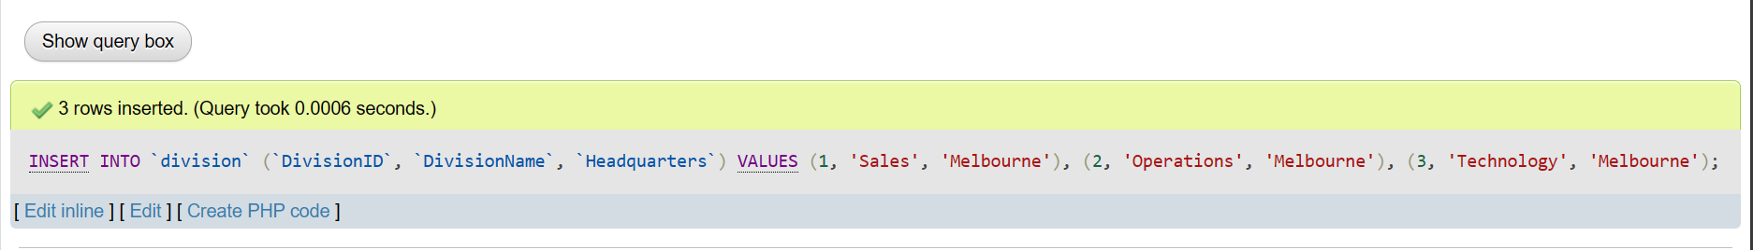

Table Employee:

INSERT INTO `employee` (`EmployeeID`, `FirstName`, `LastName`, `Position`, `DateOfBirth`, `HireDate`, `IsRover`, `DepartmentID`, `DivisionID`) VALUES

(1, 'Sushant', 'Ghimire Khatri', 'Software Engineer', '2002-08-01', '2022-08-01', ‘Yes’, 1, 2),

(2, 'Anil', 'Magar', 'Finance Manger', '2000-09-01', '2023-11-22', ‘No’ 2, 1),

(3, 'Suwesh', 'Khanal', 'Marketing Manager', '2001-04-16', '2022-09-15', ‘Yes’,3, 3);

Table: Project

INSERT INTO `project` (`ProjectName`, `StartDate`, `EndDate`) VALUES

('Financial Report', '2023-01-04', '2023-12-25'),

('Website Redesign', '2023-02-01', '2023-12-16'),

('Product Lunch', '2023-01-23', '2023-11-29');

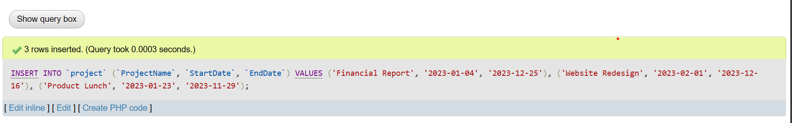

Thank You